**Ideation Phase**

**Empathize & Discover**

|  |  |
| --- | --- |
| Date | 27 June 2025 |
| Team ID | LTVIP2025TMID59160 |
| Project Name | Citizen ai – Intelligent Citizen Engagement Platform |
| Maximum Marks | 4 Marks |

**Empathy Map Canvas** : The Empathy Map Canvas for the Citizen ai – Intelligent Citizen Engagement Project is a visual framework that helps the development team deeply understand the users of the platform—primarily software developers, testers, and project managers. By capturing what users say, think, feel, and do, the canvas reveals key insights into their pain points, such as time-consuming documentation, manual bug fixing, and repetitive coding tasks. It also highlights their expectations of streamlined, intelligent tools that can automate and simplify the intelligence citizen engagement process through AI.

This empathy-driven approach ensures that Citizen AI is built not just with technical efficiency, but also with the users' real-world frustrations and goals in mind.

**Example 1:**

**Empathy Map**

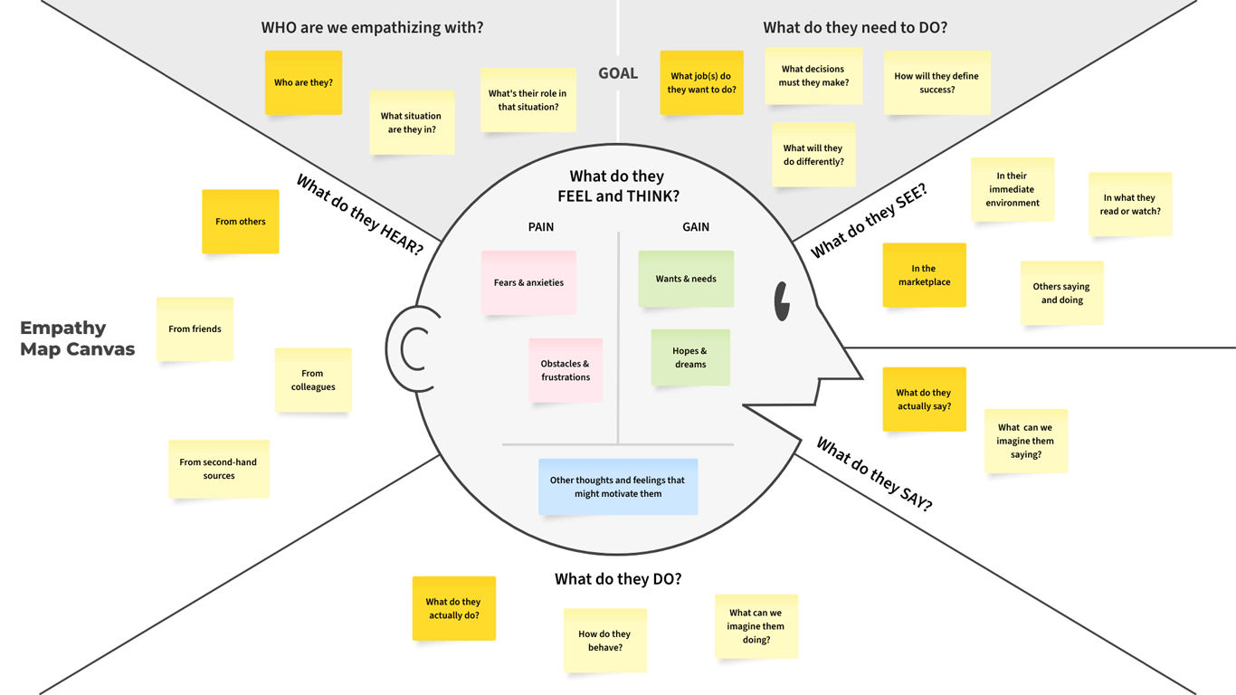

Reference Link : [<https://medium.com/@davegray/updated-empathy-map-canvas-46df22df3c8a>](https://medium.com/@davegray/updated-empathy-map-canvas-46df22df3c8a)

**Example 2:**

